Pedigree of:  AM Ch  Arubmec's Autumn Serenade  F  HM489703/03 (USA)  3 Nov 1993 | AM Ch  Jato James T  HM434545/01 (USA)  10 Sep 1992  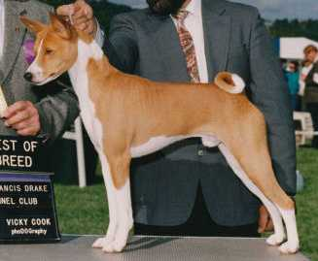 | AM Ch  Arubmec's The Victor  HD099439 (USA)  25 Sep 1983 | CAN/AM Ch  Asari's Envoy  HC856283 (USA) | AM Ch  Absinthe's Red Rocket Bellair
 |  |  |  | Asari's Neferteri
 |  |  | AM Ch  Pero's Cayenne of N'Gi  HC597505 (USA) | AM Ch  Pero's Krugerrand
AM Ch
Pero's Classy Chassis
 |  | AM Ch  Jato J'Mira  HD138622 (USA)  18 Dec 1983 | CAN/AM Ch  Asari's Envoy  HC856283 (USA) | AM Ch  Absinthe's Red Rocket Bellair
 |  |  |  | Asari's Neferteri
 |  |  | AM Ch  Delahi's M'Bari Jato  HC579788 (USA) | AM Ch  Asari's N'Tare
 |  |  |  | Delahi's Lantana
 | AM Ch  Arubmec's Intruder  HM330525/01 (USA)  25 Dec 1990 | AM Ch  Djakomba's Spotlight  HC481749 (USA)  12 Dec 1977 | AM Ch  Sirius Half-Back  HB213718 (USA) | AM Ch  Reveille Re-Up
AM Ch
Makila Motane Moke
 |  |  | AM Ch  Caucasian Ruffles  HC246168 (USA) | AM Ch  Reveille Re-Up
AM Ch
Russell's Mkewe Mfalme
 |  | AM Ch  Arubmec's Precious Thisbe  HD572533 (USA)  28 Nov 1986 | AM Ch  Arubmec's The Victor  HD099439 (USA) | CAN/AM Ch  Asari's Envoy
AM Ch
Pero's Cayenne of N'Gi
 |  |  | AM Ch  Arubmec's Mandy  HD079552 (USA) | CAN/AM Ch  Asari's Envoy
AM Ch
Pero's Cayenne of N'Gi

