Pedigree of:  AM/CAN Ch  Arubmec's Overdrive To My-Tym  (CLd)  M  HM444017/04 (USA)  14 Dec 1992  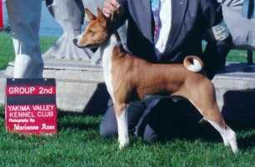 | Kibushi Spellbinder-Niger  Black Tan & White  HD907583 (USA)  9 Nov 1988  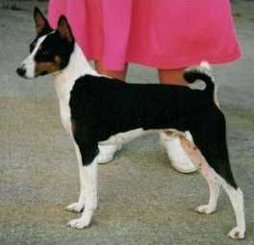 | AM Ch  Silvercreek's Kino  Black Tan & White  HD355147 (USA)  16 Jan 1986 | AM Ch  Jerlin's Mystic Mountain  HC998318 (USA) | AM Ch  Vikentor's Lucky Mountaineer
AM Ch
Sari's Mystical Mandy
 |  |  | Silvercreek's Tar Baby  HC602665 (USA) | AM Ch  Khajah's Gay Saracen
AM Ch
Silvercreek's Jungle Jane
 |  | Avongara Zamee  HD839012 (Zaire)  1 Jan 1987 | #Unknown native dog  (native)
#Unknown native bitch
(native)
 | AM Ch  Arubmec's Precious Thisbe  HD572533 (USA)  28 Nov 1986 | AM Ch  Arubmec's The Victor  HD099439 (USA)  25 Sep 1983 | CAN/AM Ch  Asari's Envoy  HC856283 (USA) | AM Ch  Absinthe's Red Rocket Bellair
 |  |  |  | Asari's Neferteri
 |  |  | AM Ch  Pero's Cayenne of N'Gi  HC597505 (USA) | AM Ch  Pero's Krugerrand
AM Ch
Pero's Classy Chassis
 |  | AM Ch  Arubmec's Mandy  HD079552 (USA)  25 Sep 1983 | CAN/AM Ch  Asari's Envoy  HC856283 (USA) | AM Ch  Absinthe's Red Rocket Bellair
 |  |  |  | Asari's Neferteri
 |  |  | AM Ch  Pero's Cayenne of N'Gi  HC597505 (USA) | AM Ch  Pero's Krugerrand
AM Ch
Pero's Classy Chassis

