Pedigree of:  Arubmec's Black-Eyed Pea  (CRd)  Black Tan & White  F  HP364043/06 (USA)  26 Dec 2009 | AM/AUS Ch  Jasiri-Sukari HR Pup N'Stuff  (CLd) (PRA -N)  HM988797/02 (USA)  29 Nov 2001  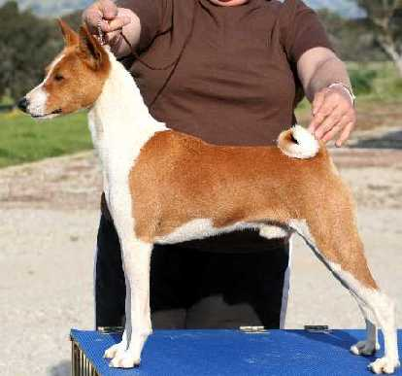 | DC  Sukari's Steven Spielbark  CD MC  HD799950 (USA)  27 Nov 1989 | AM Ch  Serengeti Cool Jazz of Woz  HD683929 (USA) | AM Ch  Music City Serengeti Jazzman
AM Ch
Serengeti Scarlet Sage
 |  |  | AM Ch  Sukari's Mindiana Jones  CD  HD221579 (USA) | AM Ch  Kazor's Dandy Deerstalker
AM Ch
Pendragon Sugarbabe of Kazor
CDX
 |  | AM Ch  Tamsala Lucy Locket  HM738408/01 (Australia)  13 Jun 1997 | Tamsala Gold Plated  V1221048 (Australia) | AUS Ch  Tamsala Jazz Rhythm
 |  |  |  | Tamsala Study Inblack
 |  |  | Tamsala Make Awish  V1446665 (Australia) | AUS Ch  Tamsala Himself
 |  |  |  | Tamsala Three Wishes of Woz
 | AM Ch  Arubmec's Final Mission  JC (pCR)  HP082818/01 (USA)  17 Dec 2003 | AM Ch  Arubmec's The Victor  HD099439 (USA)  25 Sep 1983 | CAN/AM Ch  Asari's Envoy  HC856283 (USA) | AM Ch  Absinthe's Red Rocket Bellair
 |  |  |  | Asari's Neferteri
 |  |  | AM Ch  Pero's Cayenne of N'Gi  HC597505 (USA) | AM Ch  Pero's Krugerrand
AM Ch
Pero's Classy Chassis
 |  | DC  Arubmec's Saturn Sattelite  SC (pCR)  HM868336/03 (USA)  24 Nov 1999 | AM Ch  Jasiri's Parker Steven-Son  HM556011/01 (USA) | DC  Sukari's Steven Spielbark  CD MC
AM Ch
Jasiri's General Delivery
 |  |  | AM Ch  Arubmec's Autumn Mist  (pCR)  HM649148/01 (USA) | AM Ch  Arubmec's Jon-Luke
AM Ch
Arubmec's Autumn Serenade

