Pedigree of:  AM Ch  Pero's Cayenne of N'Gi  F  HC597505 (USA)  19 Dec 1978  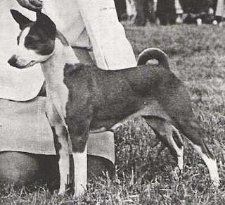 | AM Ch  Pero's Krugerrand  HC389401 (USA)  7 Dec 1976  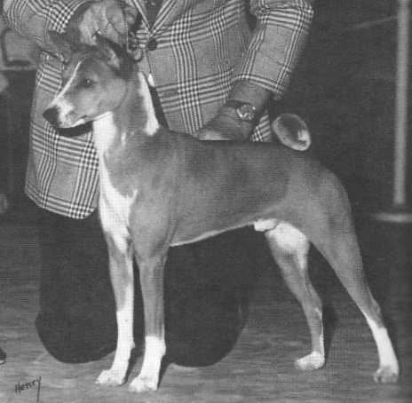 | AM/CAN Ch  Enzi Kidogo of Sun Diata  CKC 972483 (USA)  13 Dec 1975 | AM/CAN Ch  Dogo Birocco of Sun Diata  CKC 973461 (USA) | AM Ch  Fula Sirocco of the Congo
 |  |  |  | Bia of Sun Diata
 |  |  | AM Ch  B'Tasi Bronze Kianga  HB827535 (USA) | AM Ch  Fula Bronze of the Congo
 |  |  |  | Riviana Eastern Delight
 |  | AM Ch  Pero Precious Charm  HB984950 (USA)  5 Dec 1973 | AM Ch  Pero Regal Image  HB842554 (USA) | AM Ch  Jarushan's Fula Khamsin
 |  |  |  | Jarushan's Sweet Leilani
 |  |  | AM Ch  B'Tasi Sirdell  HB669241 (USA) | AM Ch  Fula Sirocco of the Congo
 |  |  |  | Riviana Eastern Delight
 | AM Ch  Pero's Classy Chassis  HC271057 (USA)  19 Oct 1975 | AM Ch  Pero Regal Image  HB842554 (USA)  8 Dec 1972 | AM Ch  Jarushan's Fula Khamsin  HB420907 (USA) | AM Ch  Fula Sirocco of the Congo
AM Ch
Fula Zephyr of the Congo
 |  |  | Jarushan's Sweet Leilani  HB330980 (USA) | AM Ch  Fula Sirocco of the Congo
 |  |  |  | Binti of the Vilima
 |  | AM Ch  B'Tasi Sirdell  HB669241 (USA)  24 Dec 1971 | AM Ch  Fula Sirocco of the Congo  HB57878 (England) | Fulamaranta of the Congo
 |  |  |  | Black Fula Dream of the Congo
 |  |  | Riviana Eastern Delight  HB409527 (England) | Riviana Golden Eagle
 |  |  |  | Riviana Shepherd's Delight

