Pedigree of:  AM Ch  Arubmec's The Victor  M  HD099439 (USA)  25 Sep 1983  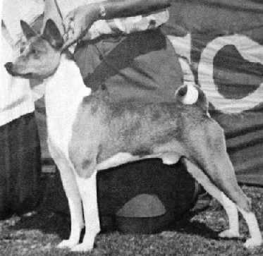 | CAN/AM Ch  Asari's Envoy  HC856283 (USA)  27 Jul 1981  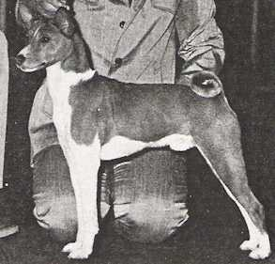 | AM Ch  Absinthe's Red Rocket Bellair  HC456964 (USA)  4 Dec 1977 | AM Ch  Reveille Re-Up  HA830160 (USA) | AM Ch  Reveille Recruit
AM Ch
Reveille Ruffles of Rose-Bay
 |  |  | AM Ch  Absinthe's Baji Nandi  HC079523 (USA) | Tawelfan Lubiluck
Majita's Winsome Yodel
CD JC
 |  | Asari's Neferteri  HC627248 (USA)  22 Dec 1978 | AM Ch  Asari's Ti-Jii  HC489511 (USA) | AM Ch  Asari's Black Aegis
 |  |  |  | Asari's Ti-Bangi of Baja
 |  |  | Kapki's Juba of Asari  HC346565 (USA) | AM Ch  Cambria's Jaja
AM Ch
Asari's Makeda
 | AM Ch  Pero's Cayenne of N'Gi  HC597505 (USA)  19 Dec 1978  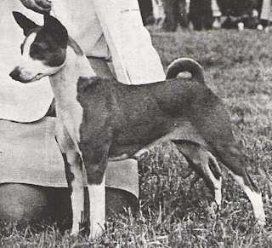 | AM Ch  Pero's Krugerrand  HC389401 (USA)  7 Dec 1976 | AM/CAN Ch  Enzi Kidogo of Sun Diata  CKC 972483 (USA) | AM/CAN Ch  Dogo Birocco of Sun Diata
AM Ch
B'Tasi Bronze Kianga
 |  |  | AM Ch  Pero Precious Charm  HB984950 (USA) | AM Ch  Pero Regal Image
AM Ch
B'Tasi Sirdell
 |  | AM Ch  Pero's Classy Chassis  HC271057 (USA)  19 Oct 1975 | AM Ch  Pero Regal Image  HB842554 (USA) | AM Ch  Jarushan's Fula Khamsin
 |  |  |  | Jarushan's Sweet Leilani
 |  |  | AM Ch  B'Tasi Sirdell  HB669241 (USA) | AM Ch  Fula Sirocco of the Congo
 |  |  |  | Riviana Eastern Delight

